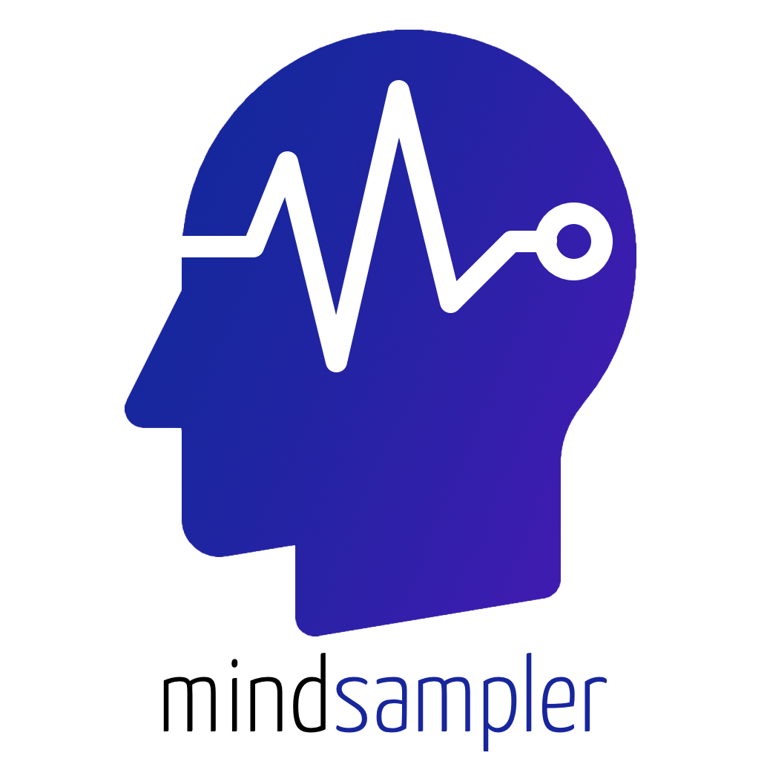

Setting Up Experience-Sampling Studies
Researchers’ Guide

Table of Content

1. Table of Content
2. Welcome
3. Understanding the MindSampler Qualtrics Templates
3.1. Embedded Variables (From MindSampler to Qualtrics)
3.2. Redirect URL (From Qualtrics to MindSampler)
3.3. Pre-loaded Items from MindSampler’s Smart Library
4. Setting Up Initial Instructions and Questions Participants See When They First Install MindSampler
5. Setting Up Instructions and Questions When Participants Click the “Take Your Pulse” Button (Manual Survey)
6. Setting Up Instructions, Questions, and Rewards When Participants Click a Push Notification (Automatic Survey)
6.1. Setting Up Response Time Limits and Reward Scheme with MindSampler
6.1.1. Implementing Reward Schemes
6.1.2. Displaying a different block
6.2. Setting the End Date and Time for Your Study
7. Passing Information from Qualtrics to MindSampler Using Query Strings
7.1. General Idea Behind Query Strings
7.2. Passing information from Qualtrics to MindSampler: A Step-by-Step Guide
8. Customizing Information Participants See on the App Home Screen
9. Advanced Features
9.1. Randomizing Participants to Different Conditions
9.2. Creating Trigger Rules to Send Follow-up Surveys
9.3. Matching Participants with a Partner
10. Integration with Prolific Academic
10.1. Running Your MindSampler Study on Prolific
10.2. R scripts to Easily Pay Prolific Participants
10.2.1. Through Bulk Payment on Prolific’s Web Page
10.2.2. Trought Prolific API

Welcome

Welcome to MindSampler, a powerful tool to streamline and enhance your experience-sampling studies. This user guide is designed to assist you in setting up your studies efficiently, maximizing participant engagement, and utilizing the full potential of this versatile application.

Launching an experience-sampling study with MindSampler is done in 3 easy steps:

- Design Your Study on Qualtrics
With MindSampler, you can design your study using your familiar Qualtrics account. Simply create your study, ensuring it's optimized for mobile display, and provide us with the URL. We recommend using our survey templates, which already include all the necessary embedded data fields to facilitate seamless data exchange. These fields will automatically capture your participants' IDs, sensor data, and when they received survey notifications. The templates also include various useful branching examples that you might find helpful in designing your experience-sampling study.

There are two templates:

- Button Qualtrics survey: This survey is displayed when participants click the "take your pulse" button on the app home screen; this survey also provides first-time instructions.

- Notification Qualtrics survey: This is the survey participants receive at random moments.

- Ask Participants to Download MindSampler
For participants to be part of your study, they need to download MindSampler and enter your study's unique code at sign-up. Once registered, they will receive fully customizable notifications at random intervals, prompting them to engage with your study. In addition, if you plan on running your study on Prolific, we have designed a specific Qualtrics survey to make your life easier:

- Prolific Qualtrics survey: This survey is posted on Prolific and guides participants through installing MindSampler. (see Page X):

We have also created a Prolific Payment Interface (HERE) to quickly compensate your participants based on how many surveys they completed using Prolific’s bulk payment option.

- Maximize Engagement
MindSampler opens your survey within the app when participants click on a notification. After completing the survey, the home screen displays customized feedback. By default, you can display the number of surveys taken and the average mood, designed to boost engagement. But you can also add other custom feedback on the home screen.

By following these steps, you'll be well on your way to running an engaging, effective, and efficient experience-sampling study using MindSampler. Happy sampling!

Understanding the MindSampler Qualtrics Templates

Welcome to the MindSampler Qualtrics Templates guide. In this document, we will cover the three main components of our templates. The first two, “Embedded Variables” and “Redirect URL,” are necessary to integrate your Qualtrics survey with MindSampler. The last component, “Preloaded Items,” is meant to offer a solid starting point for your study. Preloaded items are not necessary for your Qualtrics survey to function on MindSampler, but can save you countless hours of item selection and ensure a robust survey design.

Let's take a look at each component:

Embedded Variables (From MindSampler to Qualtrics)
To transfer relevant information from MindSampler to your Qualtrics data file, we incorporate a set of embedded variables in the survey flow. These variables are automatically populated by MindSampler. Please note that certain variables are specific to push notification surveys, while others are relevant to "pulse button" user-initiated surveys. These specific variables are included only in their respective survey templates. Below, we outline the variables and their purposes:

- automaticSurveyCount [Push Notification survey template only]: This variable tracks the total number of push notification surveys completed by participants. When participants open a push notification survey for the first time, this variable is initialized as 0. It is important to note that this variable is updated every time participants complete a survey, regardless of whether it was completed within a specific time window or if they skipped most or all questions.

- manualSurveyCount [Pulse Button survey template only]: This variable tracks the total number of user-initiated surveys participants completed by pressing the “Take Your Pulse” button. When press this button to open their first survey, this variable is initialized as 0. It is important to note that this variable is updated every time participants complete a survey, regardless of whether they skipped most or all questions.

- userId: This variable represents the unique anonymized identifier assigned to each participant. You can use this identifier to cluster or aggregate answers from the same participant.

- userEmail: This variable captures the email address used by participants to sign up on MindSampler. It can be highly useful if you need to send follow-up surveys via email (consult the Qualtrics documentation on email triggers) or if you require participant matching, such as in a couple or dyadic study. If you prefer anonymized data, or if your Institutional Review Board (IRB) mandates it, we recommend instructing participants to enter a fabricated email address during the sign-up process. Additionally, you can remove this variable from the survey flow if you do not wish to receive it in your data file.

- userSurveyId: This variable represents a unique identifier for each survey session. It helps differentiate and track individual survey instances.

- Q_Language: This variable captures the participant's language preference as set on their mobile device. MindSampler uses the same two-letter language code as Qualtrics, enabling you to utilize this variable to display your study in the participant's preferred language using Qualtrics' multilingual survey options.

- battery_level: This sensor variable denotes the percentage of battery remaining on the participant's phone.

- battery_state: This variable indicates whether the participant's phone battery is currently charging or discharging. It helps monitor the battery usage context during the survey session.

- latitude_start: This variable captures the participant's latitude location at the moment they open the survey. It provides geographic coordinates related to their initial position.

- longitude_start: This variable represents the participant's longitude location at the moment they open the survey. It provides geographical coordinates associated with their initial position.

- altitude_start: This variable indicates the participant's altitude in terms of elevation at the moment they open the survey. It provides information regarding their vertical position above sea level.

- noise_level: MindSampler samples one second of sound when participants open a survey and retrieves the average noise level in decibels. It's important to note that no actual sounds are recorded or stored for privacy reasons. The variable simply accesses the decibel levels captured by the participants' phones.

- steps_since_last_survey: This variable reflects the number of steps taken by the participant, as recorded by the phone's native pedometer, since they last answered a survey. It can be used to assess the participant's physical activity level. Please be aware that older phones may not provide step counts, resulting in a blank value for this variable.

- last_step_timestamp: This variable represents the Unix timestamp, which is a numeric value indicating the number of seconds that have elapsed since January 1, 1970 (UTC). It denotes the timestamp of the last step recorded by the participant's phone. You can use this variable to evaluate the participant's recent physical activity level. Like the previous variable, older phones may not provide step counts, resulting in a blank value.

- notif_timestamp [Push Notification survey template only]: This variable captures the Unix timestamp indicating the time at which the participant received the push notification for the specific survey. It helps track the timing of the notification delivery.

- time: This variable represents the current time recorded by Qualtrics. It allows you to reference the time within your survey for various purposes and is used to compute Response_time (see below).
Technical note: this variable is directly populated by Qualtrics, not MindSampler.

- response_time [Push Notification survey template only]: This variable calculates the time difference, in minutes, between when participants received the push notification (notif_timestamp) and when they opened the survey (time). It provides a measure to exclude responses submitted after a defined time window.
Technical note: The computation for this variable is done within Qualtrics using a JavaScript code snippet. By default, the JavaScript code is placed in the "info" question, hidden from participants. You have the flexibility to move this code to another question at the beginning of your survey if desired. Make sure that the question in which the JavaScript code is placed is consistently presented to participants in your survey (i.e., that not display or skipping logic prevent the question from being processed by Qualtrics).
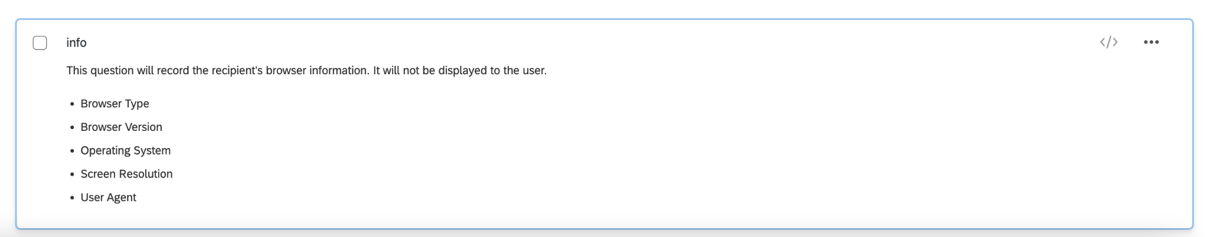
- sNotif: short for 'Start Notification', refers to the initial time in a participant's daily schedule when they begin receiving notifications from MindSampler. It marks the start of the time window for these notifications. It's important to note that participants have the flexibility to adjust this start time whenever they want in the app’s settings. Therefore the sNotif value might change over time both within and across participants.

- eNotif: short for ‘End Notification', indicates the closing time of the daily notification window in a participant's MindSampler settings. This is the time when the participant stops receiving notifications for the day. Similar to sNotif, participants have the autonomy to modify their eNotif settings at any time. Therefore the eNotif value might change over time both within and across participants.

- dNotif: short for 'Daily Notifications', is a numeric code in the MindSampler system representing the days of the week when a participant chooses to receive notifications. Each number corresponds to a specific day: 1 for Sunday, 2 for Monday, and so on, up to 7 for Saturday. The sequence of numbers in dNotif indicates the exact days the participant has selected for receiving notifications. For example, a dNotif value of 2345671 indicates that the participant receives notifications every day of the week. On the other hand, a value of 357 signifies that notifications are set for Tuesday (3), Thursday (5), and Saturday (7). Participants have the option to modify these settings at any time, which means that the dNotif values in your data can change over time, reflecting these adjustments in their notification preferences.

- nNotif: short for ‘Number of Notifications', denotes the total number of notifications a participant is set to receive from MindSampler within their specified daily time window. Again, participants can change how many times they are notified each day, at any point. Therefore the dNotif value might change over time both within and across participants.

Pro Tip: Explain why you need sensors

Participants can refuse permission to access certain sensors on their mobile devices. If your study requires specific sensor data, it is important to explain why you need them and how you will protect participants' privacy in the consent form.

Redirect URL (From Qualtrics to MindSampler)
To transfer relevant information from Qualtrics to MindSampler, we need to redirect participants at the end of the survey to a specific web address, which is "https://pulse.survey.com/". This custom redirect link serves two purposes:

- Signaling survey completion: When the redirect link is triggered, it notifies MindSampler that the survey has ended. This signal prompts the app to display its home screen and perform any necessary actions associated with completing the survey.

- Customizing information passed to MindSampler: The redirect link can be customized to transmit specific information to MindSampler. This feature allows you to pass on relevant data, such as the participant's answers to specific survey items. By including this information, you enable MindSampler to generate tailored feedback within the app based on the participant's responses. For more information on this feature, check out: Passing Information from Qualtrics to MindSampler Using Query Strings

By default, the redirect link in the templates includes a binary “point” variable (0 or 1), indicating whether the participant earns a point for completing the survey within the specified time window. The default time window is set to 15 minutes after receiving a notification, but this duration can be adjusted according to your preferences.

Pre-loaded Items from MindSampler’s Smart Library

We have preloaded our survey templates with carefully selected and scientifically-validated questions from our Smart Item Library. These items have been chosen by our team of ESM experts based on the goals and requirements of your study.

It's important to note that these items are simply suggestions meant to save you valuable time in selecting the most appropriate items for your study. Unlike the embedded data variables and the redirect URL components, they are not necessary for your Qualtrics survey to work on MindSampler. You have the flexibility to modify, add, or remove these suggested items according to your specific research needs.

Setting Up Initial Instructions and Questions Participants See When They First Install MindSampler
Upon the initial installation of the MindSampler application, participants will be automatically guided through an onboarding process for your study. This will occur right after they input the designated study code. It's important to note that the application will autonomously activate the "Take Your Pulse" feature invisibly to the user. This feature is a built-in mechanism that opens the Button Qualtrics survey linked to your study.
We recommend crafting a unique set of introductory questions or prompts to be displayed within this survey the first time participants join your study. This could include relevant information about your study and a handful of initial demographic questions to collect baseline data from participants.
MindSampler automatically keeps track of the number of times a participant has accessed the Button Qualtrics survey. This tally is stored as a variable known as manualSurveyCount. During the first application installation, this count will be equal to zero.
Leveraging this feature, you can guide first-time users to the introductory questions or instructions by employing the "branching" feature within the Survey Flow. To set this up, create a condition for "if manualSurveyCount is Equal to 0". Then, link this condition to your "first_time_open_app" block. This will ensure that these particular instructions are only shown to users during their first application use.
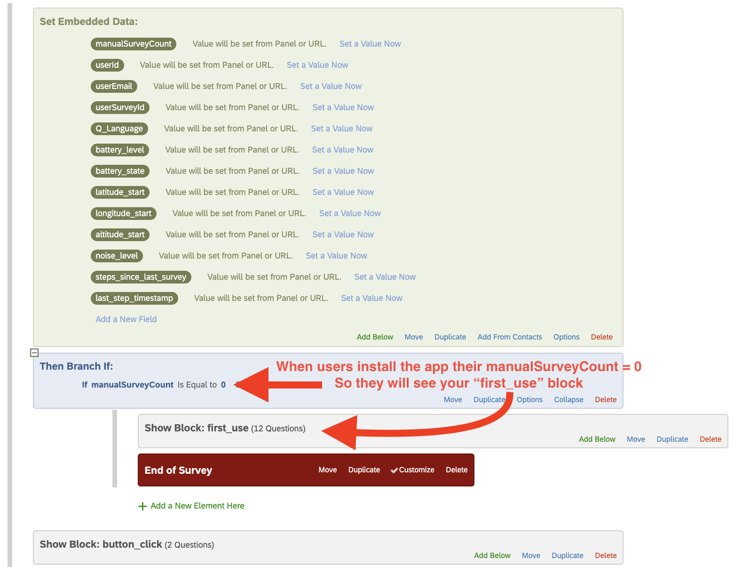

Pro Tip: Implementing Advanced Branching

Just as you can use the manualSurveyCount variable to display initial instructions or questions, this same principle can be used to introduce more complex branching scenarios. As the count increases with each time participants press the “Take Your Pulse” button and answer the associated Button Qualtrics survey, you can set conditions for the display of different sets of questions or instructions based on the manualSurveyCount value.
Here are a few examples:
- Check-in Survey Questions - You could set a block of questions to be shown only when the manualSurveyCount equals to a certain value, say after 5 surveys. This could allow a quick check-in on participants' progress or feedback on the study so far. To set this up, create a condition in your Survey Flow for "if manualSurveyCount is Equal to 5". Then, link this condition to your "mid_point" block (or any title you choose).

- Exit Survey Questions - You may want to show a set of exit questions or final instructions when a participant has reached a certain number of survey completions. For example, after 10 completions (manualSurveyCount = 10), you might want to ask participants to share their overall experience or thoughts. In this case, establish a condition for "if manualSurveyCount is Equal to 10" and link it to your "exit_survey" block (or a similar title).
By leveraging the manualSurveyCount variable, you can enhance the participant's journey through your study, providing specific questions or instructions at the most appropriate times. This dynamic branching technique is powerful for creating a customized and engaging user experience with MindSampler.

Setting Up Instructions and Questions When Participants Click the “Take Your Pulse” Button (Manual Survey)

TO DO

Setting Up Instructions, Questions, and Rewards When Participants Click a Push Notification (Automatic Survey)

Setting Up Response Time Limits and Reward Scheme with MindSampler
To enhance the relevance and accuracy of participant responses, we recommend introducing a short response window after each notification (Kuppens, 2021). Not only does this create timely engagement from participants, but it also ensures that the data collected genuinely reflects their current situation. Besides, without these time restraints, you might find yourself with a heap of responses gathered from the most popular "thinking throne" - the bathroom! We're sure you'd prefer insights from the broader world.

In MindSampler, you can set the maximum response time and design associated reward schemes within the survey flow of your Notification Qualtrics survey. There are two ways you can do it:

Implementing Reward Schemes

A first method – implemented by default in the Notification Qualtrics survey template – is to use MindSampler’s built-in “Reward System” to incentivize prompt responses.

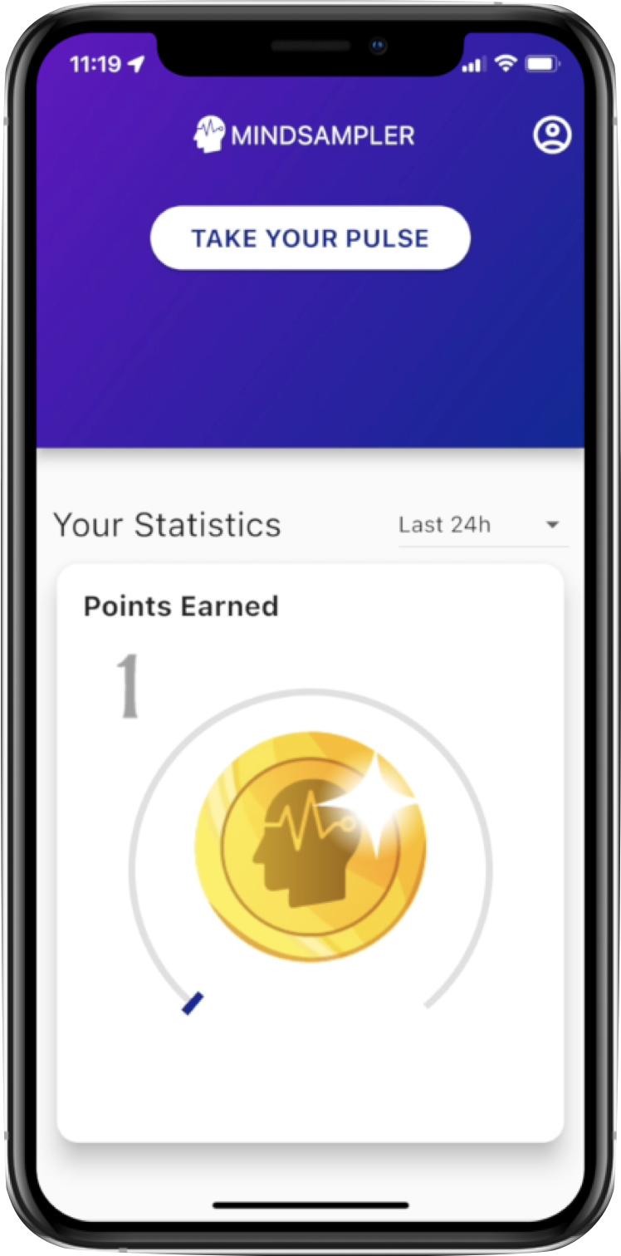
If you enable the Reward System, this is what participants see on the home screen of the App
By default, participants earn one MindSampler point if they respond within 15 minutes of receiving a push notification. However, they don't earn any points for responses provided after this 15-minute window. You can change these values in the survey flow of your Notification Qualtrics survey.

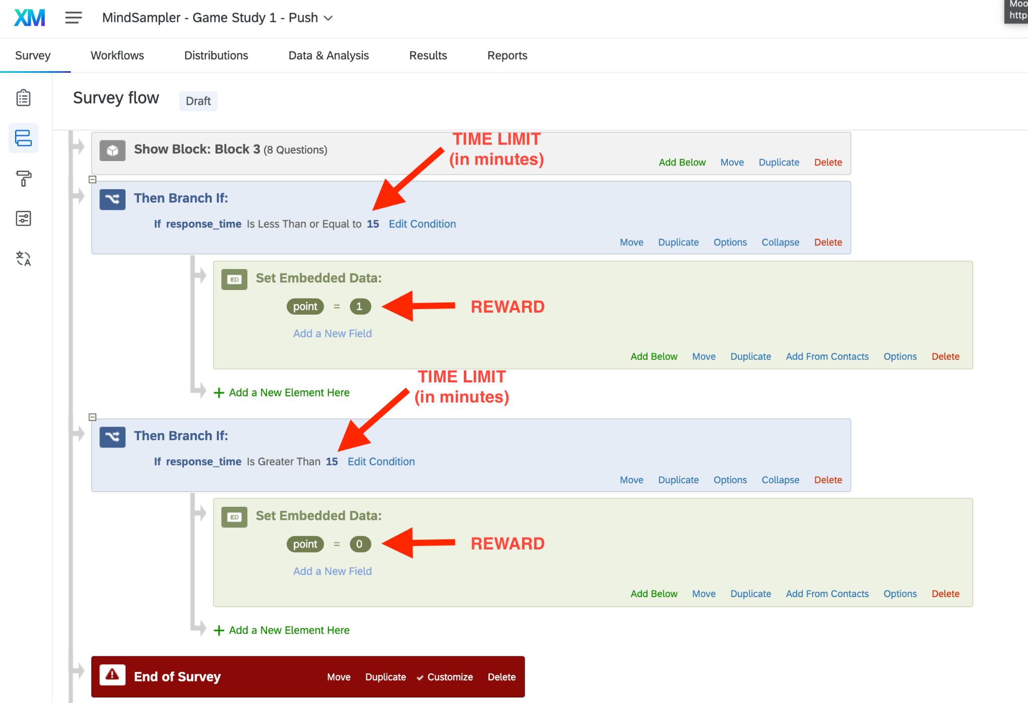

Points can be converted into a financial bonus at the end of your study (see section XXX: How to Easily Pay Participants on Prolific).

Pro Tip: Implementing a Tiered Reward System

To add an element of motivation, you could set up a system where the number of points earned decreases as more time passes from the notification. For example:

- Responses within 5 minutes: 3 coins
- Responses within 10 minutes: 2 coins
- Responses within 15 minutes: 1 coin
- Responses after 15 minutes: 0 coins

Displaying a different block

A second method – not implemented by default in the Notification Qualtrics survey template – is to determine a specific timeframe for participants to respond to the notifications. After this time elapses, you can display a survey block indicating the present survey is inaccessible and ask for faster reactions next time.

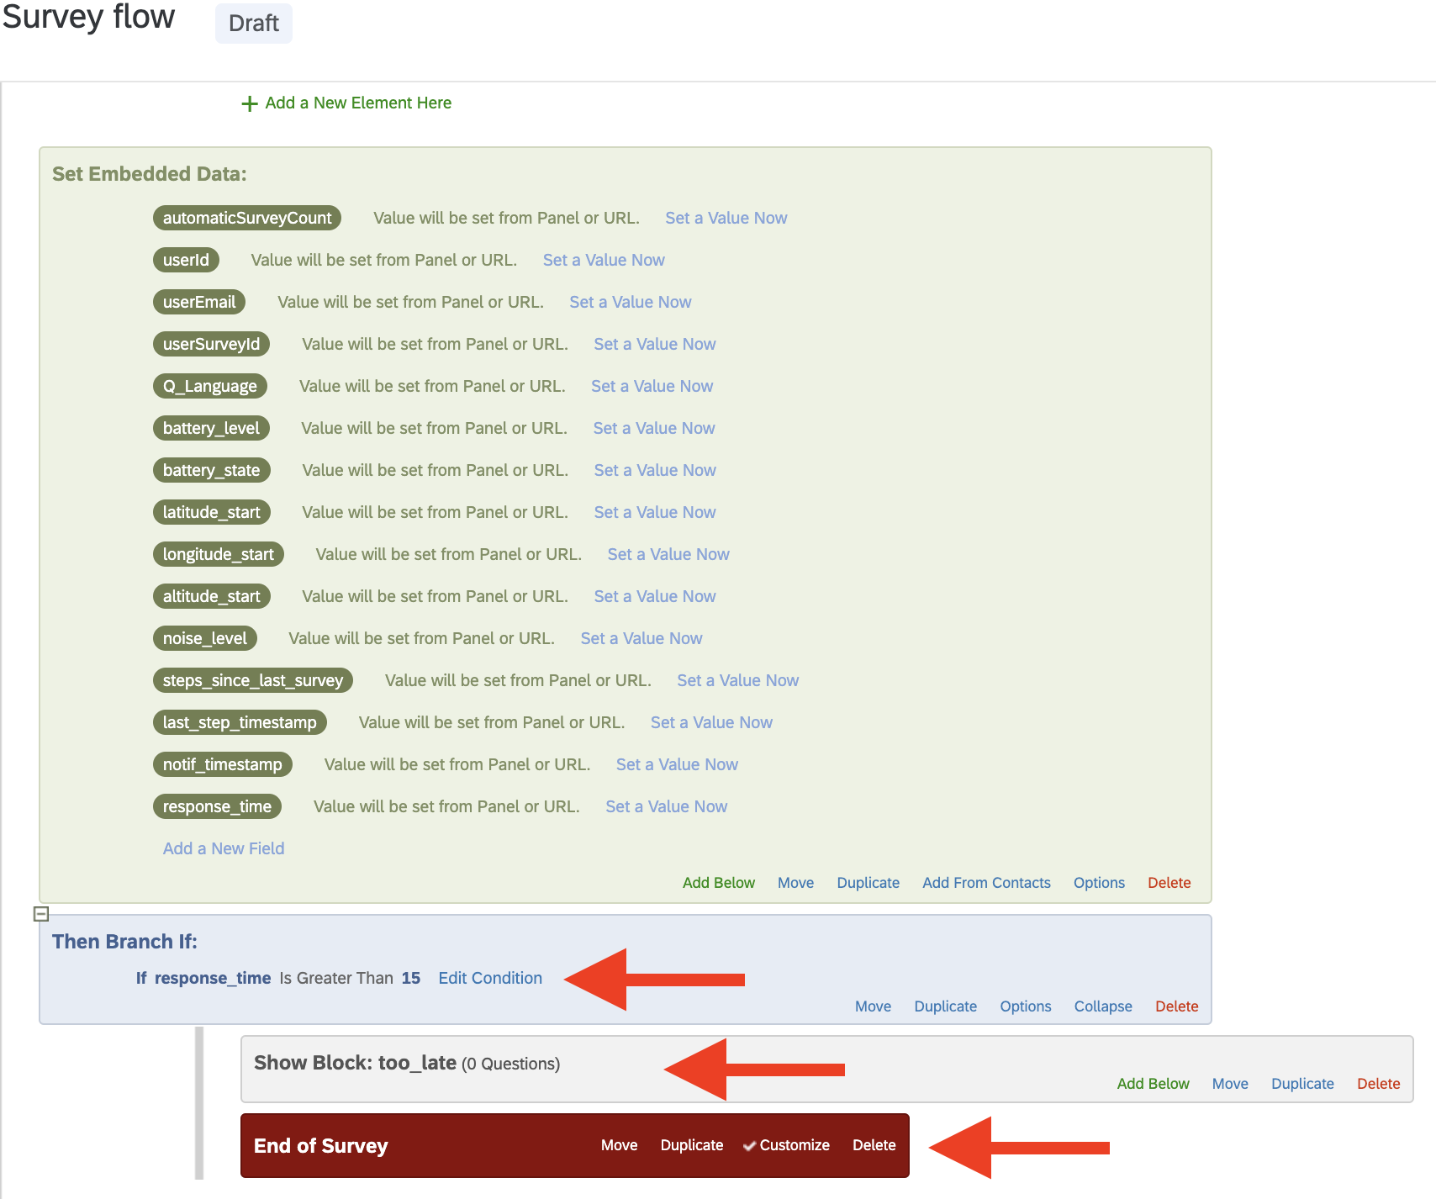

Remember, by effectively combining a maximum response time with a reward scheme, you can significantly improve the pace and quality of the data gathered through the MindSampler application.

Setting the End Date and Time for Your Study

You can define a precise end date and time for your study in MindSampler, which can be essential if you recruit participants from Mturk or Prolific. This termination point can be customized in the survey flow of both your Notification Qualtrics survey and Button Qualtrics survey. To make this change, you must adjust the time condition to your preferred date and time, utilizing a specific format.

The format you should use is as follows:

YYYY-MM-DD-THH:MM:SS+TZ

Here's a breakdown of what each component represents:
- YYYY-MM-DD (Highlighted in BLUE): This is the date in Year-Month-Day format.
For example, 2023-05-13 represents May 13, 2023.

- THH:MM:SS (Highlighted in RED): This is the time in 24-hour format, represented as Hours:Minutes:Seconds.
For example, T22:00:23 represents 10:00:23 PM.

- +TZ (Highlighted in GREEN): This represents the time zone offset from GMT.
For example, +02:00 indicates that the time is set to GMT + 2.

So, if you want your study to end on June 20, 2024, at 10 PM GMT + 5, you would format it as: 2024-06-20-T22:00:00+05:00

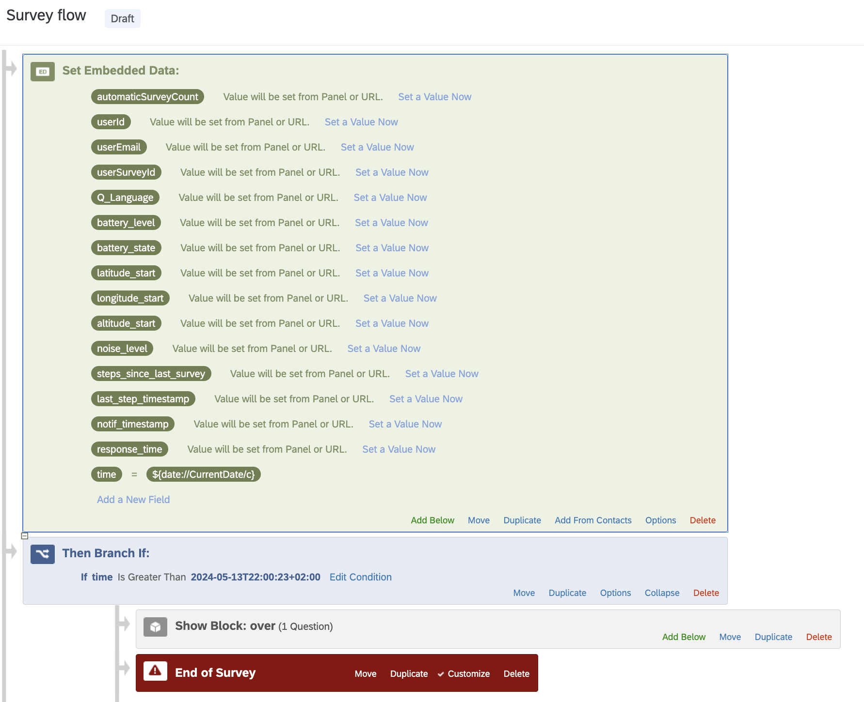

Pass that time, participants will not be allowed to answer items. Instead, they will see the following block (which you can customize)

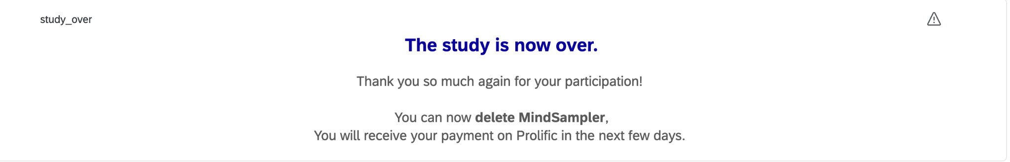

Remember, setting an accurate end date and time is vital for the smooth completion of your study. Ensure you use the correct format to avoid any complications or misinterpretations.

Passing Information from Qualtrics to MindSampler Using Query Strings

MindSampler allows you to seamlessly integrate Qualtrics surveys and provide a personalized user experience by displaying tailored data on the home screen and triggering specific push notifications based on survey responses. This is achieved by using Qualtrics' query string function, which allows you to pass specific data from your Qualtrics survey to MindSampler.

General Idea Behind Query Strings
Query strings are part of a URL that comes after a ? and contain data in the form of key-value pairs. This data can be used to pass information from your Qualtrics survey to MindSampler. Here is a basic example of what a URL with a query string might look like:

https://pulse.survey.com/?mood=75

In this example, mood=75 is the query string, which passes the information that the participant's response to the mood item is 75.
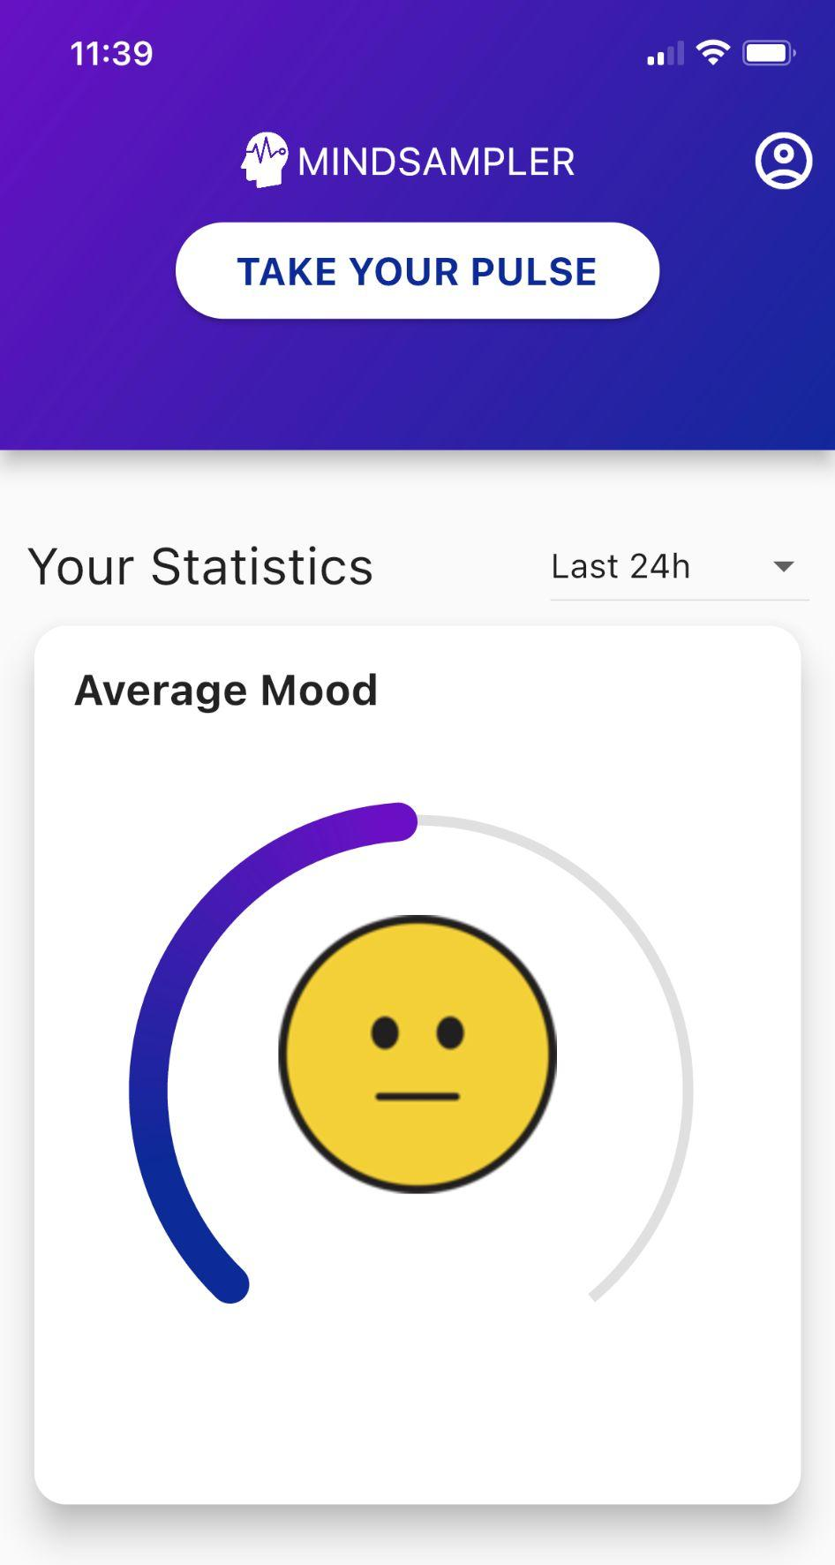
Once the information is passed from Qualtrics to MindSampler via the redirect URL and the query strings, MindSampler can use this information to display personalized user data on the app home screen. For instance, if you pass on the participant's mood score from your Qualtrics survey, you can then display the participant's average mood in a visual gauge on the MindSampler app.

Currently, the types of feedback you can display on the MindSampler home screen include:

- A 0 to 100 Gauge: This gauge can show a range of data. For instance, it could represent a participant's average mood score. The title and images of the gauge are fully customizable to suit your research needs.
- Top Frequency of Responses: This option allows you to display the top X most frequent (or least frequent) responses to a particular question. For example, you could show the top three most selected activities by the participant.
- Free Text: You can also display any text information that you have collected from the participant.

Additionally, MindSampler can use the passed information to create rules that trigger follow-up push notifications. For example, if a participant's latest answer to the mood question (or their average mood) is below a certain value, you could program MindSampler to send a push notification linking to a follow-up survey. This can allow for immediate and personalized feedback or follow-up based on the participant's responses, improving the interactivity and efficacy of your research process.

Important

Remember, the variable names you create in the redirect URL should match those you use in MindSampler to create your custom feedback. If you use `?mood=6` in your redirect URL, make sure to use the variable name "mood" in MindSampler when you design a custom gauge graph or a rule to trigger a follow-up survey based on this variable.

Passing information from Qualtrics to MindSampler: A Step-by-Step Guide

1. Generate the Piped Text Code: First, you need to generate the piped text code for each data piece you want to pass. This could be answers to survey questions, embedded data, or any other information collected with the response. Make sure to save these codes for later use.

For instance, if you want to pass along the respondent’s answer to one of your survey questions and one of your embedded data fields, your piped text for the selected survey question might look like ${q://QID7/ChoiceGroup/SelectedChoices} and your piped text for the embedded data field might look like ${e://Field/point} .

2. Prepare the Redirect URL: In this case, your redirect URL is https://pulse.survey.com/ . Append a question mark ? at the end of this URL.

3. Add Variable Names: Next, type the name of the variable you want to pass after the question mark. Again, this variable name should match the one you will use in MindSampler to create your custom feedback.

For example, if you want to pass the participant's answer to an extraversion item from your Qualtrics survey to MindSampler, and you use ?extra in your redirect URL, make sure to use the variable name "extra" in MindSampler when you design a custom gauge graph or a rule to trigger a follow-up survey based on this variable.

4. Assign Values to the Variables: Add an equal sign `=` after the variable name and then paste the piped text code for the variable's value. Your URL should now look like this: `https://pulse.survey.com/?extra=${q://QID7/ChoiceGroup/SelectedChoices}`.

5. Pass Additional Variables: Use an ampersand `&` instead of a question mark `?` to pass additional variables, and repeat steps 3 and 4. For instance, to pass the value of an embedded field capturing whether the participant earns a point for completing the survey on time, your URL will look like this: https://pulse.survey.com/?extra=${q://QID7/ChoiceGroup/SelectedChoices}&point=${e://Field/point}.

6. Finalize and Use the URL: Paste your completed URL in the appropriate survey termination area in Qualtrics.

By default, the End of Survey options at the bottom of the survey editor apply to all respondents. However, if you want to customize the ending experience for a subset of respondents, you can set a unique branch with its own 'End of Survey' element for each possible ending in your survey flow.

Note that the settings in this 'End of Survey' element will override your main end-of-survey options when 'Override Survey Options' is selected. In these cases, you would use the custom URL you've created in the respective 'End of Survey' element for each unique branch in the survey flow.

Troubleshooting (from Qualtrics)

If your query string is not working, it might have to do with how your piped text is formatted. A best practice is to add `?format=urlencode` to the end of piped text values, before the last bracket. This ensures values with spaces and special characters carry over properly into the query string. For example, pull embedded data called Department into your query string by using `${e://Field/Department?format=urlencode}` instead of `${e://Field/Department}`. However, don’t add `format=urlencode` to Email fields. This will convert the `@` symbol to `%40`.

You can find more detailed information about Query String on the dedicated Qualtrics Webpage.

Customizing Information Participants See on the App Home Screen

To do

Advanced Features

Randomizing Participants to Different Conditions
To do

Creating Trigger Rules to Send Follow-up Surveys
To do

Matching Participants with a Partner
To do

Integration with Prolific Academic

Running Your MindSampler Study on Prolific

R scripts to Easily Pay Prolific Participants

Through Bulk Payment on Prolific’s Web Page

Trought Prolific API

